Measuring Association between Facebook Use

and Self-Esteem

|  | Sigfried Gold  September 9, 2018  INST627  sigfried@sigfried |  |
| --- | --- | --- |

# INTRODUCTION

The social and psychological effects of social media use are the subject of a burgeoning literature—academic, journalistic, and online—as social media tools penetrate larger markets and the companies promulgating them have become some of the richest and most powerful organizations in the world. This paper draws on existing data to explore a possible association between Facebook use and self-esteem. Specifically, we hypothesize that heavy Facebook use is correlated with low self-esteem.

## Methods

As the context for the current study is a homework assignment for a course in Data Analytics: IRB approval is not necessary, an existing data set has been provided, the scope of analysis will be limited to a single pair of explanatory and response variables, and the methods will not be justified by consideration of relevant literature.

The data were collected by Dr. Jessica Vitak in 2010 in the form of survey results from 437 students at Michigan State University. The survey includes 151 questions. Identifying information has been removed from the results, leaving no evidence as to whether subjects were polled repeatedly, but it appears there is only one response per subject, collected in a single survey administration. It is not apparent from the 437-response sample how the subjects were selected or what larger population they are meant to represent. Regardless of how the subjects were originally chosen or how the data were originally collected, for the context of the present analysis, the study is observational and retrospective.

The survey includes dozens of questions pertinent to our analysis, including 93 related to Facebook use and 7 directly addressing self-esteem. The bar plots in Figure 1 show that responses to the 7 self-esteem questions are relatively consistent, except for a few noticeable differences that can inform our choice of a single question for analysis.

The first two questions (Q51, “person of worth” and Q52, “good qualities”) received no “Strongly Disagree” responses, suggesting that these questions may be less sensitive to low self-esteem than the others. On that count, the two reversed questions (Q54, “failure” and Q57, “not much to be proud of”) show the greatest endorsement for low self-esteem and may capture low self-esteem better than others.

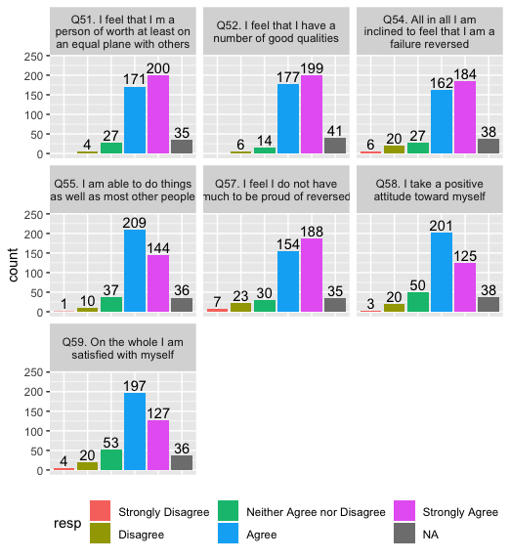

Figure 1. Self-esteem measures.

Four questions (Q51, Q52, Q54, Q57) received more Strongly Agree than agree as opposed to Q55, Q58, and Q59 which show the reverse. These latter also show higher endorsement for Neither. If we were interested in students with the lowest self-esteem, we might focus on Q54 and Q57, despite the fact that they represent a small portion of the sample. However, unless we suspect that Facebook use has a catastrophic effect on students’ self-esteem, which seems unlikely, we would do better to focus on Q55, Q58, and Q59 as they seem to do better at capturing gradations between levels of high self-esteem, which are observable in a larger portion of the sample.

 



# PAGE SIZE and columns

On each page your material should fit within a rectangle of 7 x 9.15 in (18 x 23.2 cm), centered on a US letter page (8.5x11 in), beginning 0.85 in (2.2 cm) from the top of the page, with a 0.3 in (0.85 cm) space between two 3.35 in (8.4 cm) columns. Right margins should be justified, not ragged. Please be sure your document and PDF are US letter and not A4.

# TYPESET TEXT

The styles contained in this document have been modified from the default styles to reflect ACM formatting conventions. For example, content paragraphs like this one are formatted using the Normal style.

## Title and Authors

Your paper’s title, authors, and affiliations should run across the full width of the page in a single column 7 in (17.8 cm) wide. The title should be in Helvetica or Arial 18-point bold (the Title style in this document). Authors’ names should be in Times New Roman or Times Roman 12-point bold (Author Name style), and affiliations in the font as 12-point regular (Author Affiliation style).

To position names and addresses, use a single-row table with invisible borders, as in this document. For more than three authors, you may have to place some address information in a footnote, or in a named section at the end of your paper. Names may optionally be placed in a single centered row instead of at the top of each column. Leave one 10-point line of white space below the last line of affiliations.

**Adding and Removing Author Fields Above**

If you need a 4th block for an additional author with a different affiliation, click on the table, click “layout” under “table tools”, and click “insert left” or “insert right”. Then right-click anywhere on the table, click “Table Properties”, and within the “Table” tab, click the tab box for “Preferred Width” and enter “7”.

If you need author blocks for only 1 or 2 authors, you should remove one column from the table. Right-click in the unwanted cell, click “Delete Cell”, click “Delete entire column”, then click “OK”. Repeat if necessary.

## Abstract and Keywords

Every submission should begin with an abstract of about 150 words, followed by a set of keywords. The abstract and keywords should be placed in the left column of the first page under the left half of the title. The abstract should be a concise statement of the problem, approach, and conclusions of the work described. It should clearly state the paper’s contribution to the field of HCI.

## Normal or Body Text

Please use 10-point Times New Roman or Times Roman font (the Normal style) or, if this is unavailable, another proportional font with serifs, as close as possible in appearance to Times New Roman 10-point. Other than Helvetica or Arial headings, please use sans-serif or non-proportional fonts only for special purposes, such as source code text.

## First Page Copyright Notice

This sample word document has the correct ACM SIGCHI copyright notice in place (see page 1, bottom of column 1). Accepted papers will be distributed in the conference publications. They will also be placed in the ACM Digital Library, where they will remain accessible to thousands of researchers and practitioners worldwide. ACM’s copyright and permissions policy is here:

<http://acm.org/publications/policies/copyright_policy>

## Subsequent Pages

On pages beyond the first, start at the top of the page and continue in double-column format. The two columns on the last page should be of approximately equal length.

# SECTIONS

The heading of a section should be in Arial 9-point bold, all in capitals (Heading 1 style). Sections should not be numbered[1].

## Subsections

Headings of subsections should be in Arial 9-point bold with initial letters capitalized (Heading 2 style). For sub-sections and sub-subsections, a word like *the* or *of* is not capitalized unless it is the first word of the heading.

### Sub-subsections

Headings for sub-subsections should be in Arial 9-point italic with initial letters capitalized (Heading 3 style).

# FIGURES and CAPTIONS

We recommend you place figures and tables at the top or bottom of the appropriate column or columns, on the same page as the relevant text (see Figure 1). You may wish for a figure or table to extend across both columns, to a maximum width of two columns, or 17.78 cm (7 in.).

Captions should be Times New Roman 9-point bold (Caption style). They should be numbered (e.g., “Table 1” or “Figure 2”), centered, and placed beneath the figure or table. The words “Figure” and “Table” should be spelled out (e.g., “Figure” rather than “Fig.”) wherever they occur.

All figures should also include alt text for improved accessibility. In Word, right click the figure, and select Format Picture | Layout | Alt Text). Papers and notes may use color figures, which are included in the page limit; the figures must be usable when printed in black-and-white in the proceedings.



Figure 2. Use high-resolution images, 300+ dpi, legible if printed in color or black-and-white. Number all figures and include captions below, using Insert, Caption. All 1-line captions should be centered; justify longer captions.

## Inserting Images

Occasionally MS Word generates larger-than-necessary PDF files when images inserted into the document are manipulated in MS Word. To minimize this problem, use an image editing tool to resize the image at the appropriate printing resolution (usually 300 dpi), and then insert the image into Word using Insert | Picture | From File.

## Table Style

The text of tables will format better if you use the Table Text style (as in Table 1). For improved accessibility, header rows of tables should be marked. In Word, right-click a header row, and select Table Properties | Row | Repeat as header row at the top of each page. All tables should include alt text for accessibility (Table Properties | Alt Text).

# QUOTES

|  |  | Test conditions | |
| --- | --- | --- | --- |
| Name | First | Second | Final |
| Marsden | 223.0 | 44 | 432,321 |
| Nass | 22.2 | 16 | 234,333 |
| Borriello | 22.9 | 11 | 93,123 |
| Karat | 34.9 | 2200 | 103,322 |

Table 1. Table captions should be placed below the table. We recommend table lines be 1 pt, 75% grey. Minimize use of unnecessary table lines. Avoid spurious degrees of precision. For larger tables, consider banded rows (click Tables, Banded Rows) to guide the eye. In Word, we recommend using the Table Grid - SIGCHI table format.

Quotes may be italicized and “*placed inline”* (Anab, 22F).

Longer quotes, when placed in their own paragraph, need not be italicized or in quotation marks. (Ramon, 39M).

# LANGUAGE, STYLE AND CONTENT

The written and spoken language of SIGCHI is English. Spelling and punctuation may use any dialect of English (e.g., British, Canadian, US, etc.) provided this is done consistently. Hyphenation is optional. To ensure suitability for an international audience, please:

* Write in a straightforward style.
* Try to avoid long or complex sentence structures.
* Use common and basic vocabulary (e.g., use the word “unusual” rather than the word “arcane”).
* Briefly define or explain all technical terms that may be unfamiliar to readers.
* Explain all acronyms the first time they are used in your text—e.g., “Digital Signal Processing (DSP)”.
* Explain local references (e.g., not everyone knows all city names in a particular country).
* Explain “insider” comments. Ensure that your whole audience understands any reference whose meaning you do not describe (e.g., do not assume that everyone has used an Android phone, or a particular application).
* Explain colloquial language and puns. Understanding phrases like “red herring” may require a local knowledge of English. Humor and irony are difficult to translate.
* Use unambiguous forms for culturally localized concepts, such as times, dates, currencies, and numbers (e.g., “1-5- 97” or “5/1/97” may mean 5 January or 1 May, and “seven o’clock” may mean 7:00 am or 19:00). For currencies, indicate equivalences: “Participants were paid ₩22, or roughly US$29.”
* Be careful with the use of gender-specific pronouns (he, she) and other gendered words (chairman, manpower, man-months). Use inclusive language that is gender-neutral (e.g., she or he, they, s/he, chair, staff, staff-hours, person-years). See the Guidelines for Bias-Free Writing for further advice and examples regarding gender and other personal attributes [9]. Be particularly aware of considerations around writing about people with disabilities.
* If possible, use the full (extended) alphabetic character set for names of persons, institutions, and places (e.g., Grønbæk, Lafreniére, Sánchez, Nguyễn, Universität, Weißenbach, Züllighoven, Århus, etc.). These characters are already included in most versions and variants of Times, Helvetica, and Arial fonts.

# ACCESSIBILITY

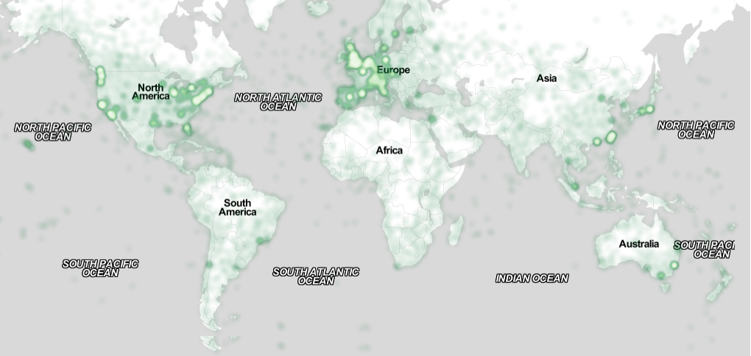

Figure 3: Sample of a wide figure. Be sure to place at the top or bottom of the page. Ensure that important information is legible in both black-and-white and color printing. Placing images and their captions within text boxes can make document management easier. Image: CC-BY-ND ayman on Flickr.

The Executive Council of SIGCHI has committed to making SIGCHI conferences more inclusive for researchers, practitioners, and educators with disabilities. As a part of this goal, the all authors are asked to work on improving the accessibility of their submissions. Specifically, we encourage authors to carry out the following five steps:

1. Add alternative text to all figures
2. Mark table headings
3. Generate a tagged PDF
4. Verify the default language
5. Set the tab order to “Use Document Structure”

For more information and links to instructions and resources, please see: <http://chi2016.acm.org/accessibility>.

# Page Numbering, Headers, and Footers

Your final submission should not contain footer or header information at the top or bottom of each page. Specifically, your final submission should not include page numbers. Initial submissions may include page numbers, but these *must* be removed for camera-ready. Page numbers will be added to the PDF when the proceedings are assembled.

# Producing and testing PDF files

We recommend that you produce a PDF version of your submission well before the final deadline. Your PDF file must be ACM DL Compliant. The requirements for an ACM Compliant PDF are available at:

<http://sheridanprinting.com/typedept/ACM-distilling-settings.htm>

When creating your PDF from Word, ensure that you generate a tagged PDF from improved accessibility. This can be done by using the Adobe PDF add-in, also called PDFMaker. Select Acrobat | Preferences and ensure that “Enable Accessibility and Reflow with tagged Adobe PDF” is selected. You can then generate a tagged PDF by selecting “Create PDF” from the Acrobat ribbon. Test your PDF file by viewing or printing it with the same software the publisher will use, Adobe Acrobat Reader Version 10, which is widely available at no cost. Note that most reviewers will use a North American/European version of Acrobat Reader, so please check your PDF accordingly.

# Conclusion

It is important that you write for the SIGCHI audience. Please read previous years’ proceedings to understand the writing style and conventions that successful authors have used. State clearly what you have done, not merely what you plan to do, and explain how your work is different from previously published work, i.e., *the unique contribution that your work makes to the field*. Please consider what the reader will learn from your submission, and how they will find your work useful. If you write with these questions in mind, your work is more likely to be successful, both in being accepted into the conference, and in influencing the work of our field.

# ACKNOWLEDGMENTS

Sample text: We thank all the volunteers, and all publications support and staff, who wrote and provided helpful comments on previous versions of this document. Authors 1, 2, and 3 gratefully acknowledge the grant from NSF (#1234-2012-ABC). This is just an example.

# References format

Your references should be published materials accessible to the public. Internal technical reports may be cited only if they are easily accessible and may be obtained by any reader for a nominal fee. Proprietary information may not be cited. Private communications should be acknowledged in the main text, not referenced (e.g., [Golovchinsky, personal communication]). References *must* be the same font size as other body text. References should be in alphabetical order by last name of first author. Use a numbered list of references at the end of the article, ordered alphabetically by last name of first author, and referenced by numbers in brackets. For papers from conference proceedings, include the title of the paper and the name of the conference. Do not include the location of the conference or the exact date; do include the page numbers if available. References should be in ACM citation format: <http://acm.org/publications/submissions/latex_style>. This includes citations to internet resources [1,4,9] according to ACM format, although it is often appropriate to include URLs directly in the text, as above. Example reference formatting for individual journal articles [3], articles in conference proceedings [7], books [10], theses [11], book chapters [12], an entire journal issue [6], websites [1,4], tweets [1], patents [5], games [8], and online videos [9] is given here. This formatting is a slightly edited version of the format automatically generated by the ACM Digital Library (http://dl.acm.org) as “ACM Ref”. DOI or URL links, and authors’ full first names, are optional but encouraged. Do your best! Your paper won’t get rejected for not having DOI links or authors’ first names. Note that the Hyperlink style used throughout this document uses blue links; however, URLs in the references section may appear in black.

# REFERENCES

1. @_CHINOSAUR. 2014. VENUE IS TOO COLD. #BINGO #CHI2016. Tweet. (1 May, 2014). Retrieved February 2, 2014 from https://twitter.com/_CHINOSAUR/status/461864317415989248
2. ACM. How to Classify Works Using ACM’s Computing Classification System. 2014. Retrieved August 22, 2014 from [http://www.acm.org/class/how_to_use.html](http://www.acm.org/class/how_to_use.html%20)
3. R. E. Anderson. 1992. Social impacts of computing: Codes of professional ethics. *Soc Sci Comput Rev* 10, 2: 453-469.
4. Anna Cavender, Shari Trewin, Vicki Hanson. 2014. Accessible Writing Guide. Retrieved August 22, 2014 from <http://www.sigaccess.org/welcome-to-sigaccess/resources/accessible-writing-guide/>
5. Morton L. Heilig. 1962. Sensorama Simulator, U.S. Patent 3,050,870, Filed January 10, 1961, issued August 28, 1962.
6. Jofish Kaye and Paul Dourish. 2014. Special issue on science fiction and ubiquitous computing. *Personal Ubiquitous Comput*. 18, 4 (April 2014), 765-766. <http://dx.doi.org/10.1007/s00779-014-0773-4>
7. Scott R. Klemmer, Michael Thomsen, Ethan Phelps-Goodman, Robert Lee, and James A. Landay. 2002. Where do web sites come from?: capturing and interacting with design history. In *Proceedings of the SIGCHI Conference on Human Factors in Computing Systems* (CHI '02), 1-8. <http://doi.acm.org/10.1145/503376.503378>
8. Nintendo R&D1 and Intelligent Systems. 1994. *Super Metroid*. Game [SNES]. (18 April 1994). Nintendo, Kyoto, Japan. Played August 2011.
9. Psy. 2012. Gangnam Style. Video. (15 July 2012.). Retrieved August 22, 2014 from <https://www.youtube.com/watch?v=9bZkp7q19f0>
10. Marilyn Schwartz. 1995. *Guidelines for Bias-Free Writing.* Indiana University Press.
11. Ivan E. Sutherland. 1963. *Sketchpad, a Man-Machine Graphical Communication System*. Ph.D. Dissertation. Massachusetts Institute of Technology, Cambridge, MA.
12. Langdon Winner. 1999. Do artifacts have politics? In *The Social Shaping of Technology* (2nd. ed.), Donald MacKenzie and Judy Wajcman (eds.). Open University Press, Buckingham, UK, 28-40.

**Columns on the last page should be of approximately equal length. Remove this line before submission.**

1. Use footnotes sparingly, if at all.